Program 1: Program to enter two numbers and print the arithmetic operations like +,-,\*, /, // and %.

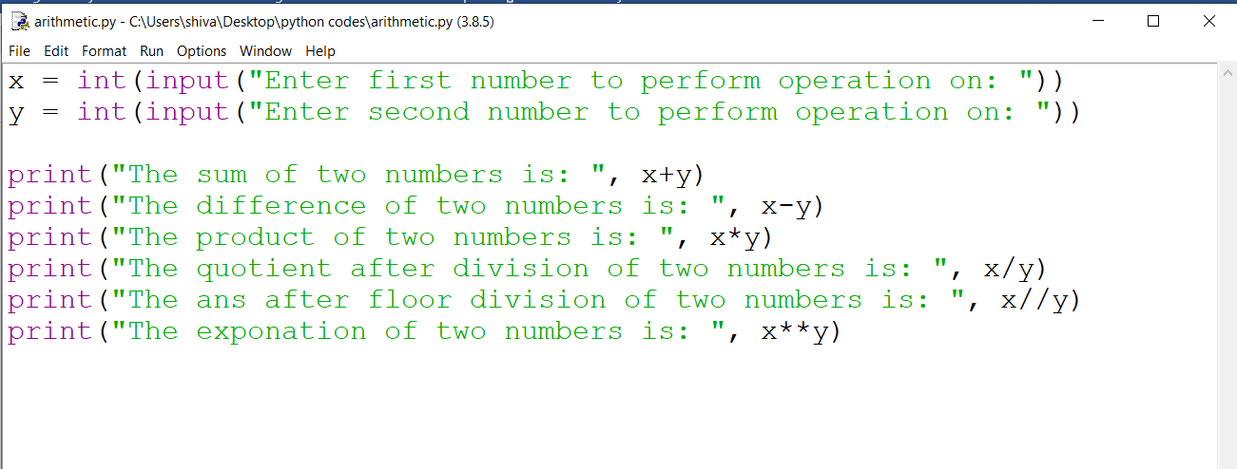

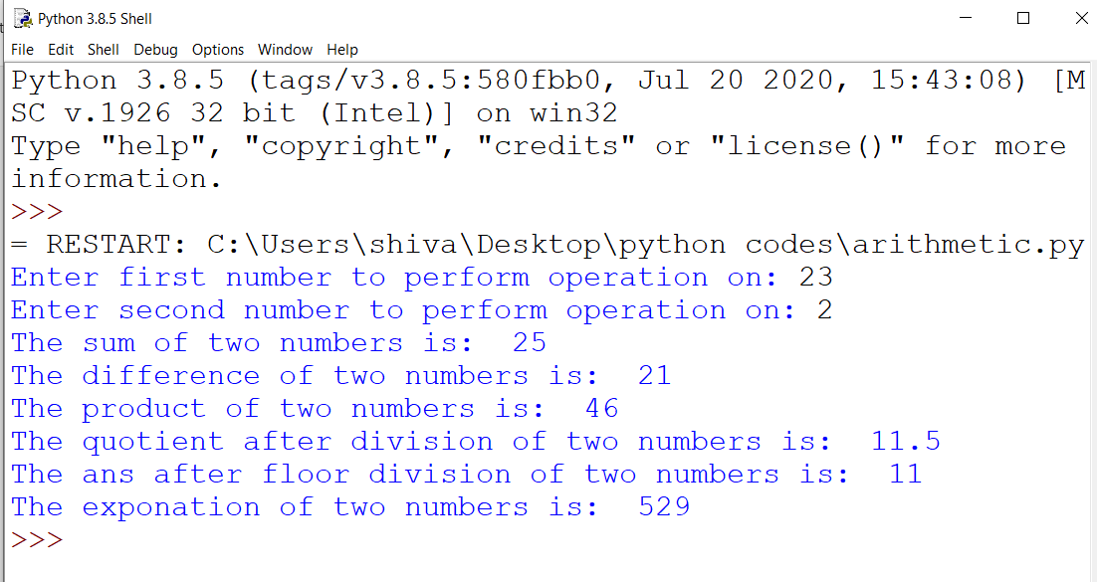

Program 2: Write a python program by defining a function to sum the sequence given below. Take the input n from the user. 1+1/1!+1/2!+1/3!+⋯+1/n!

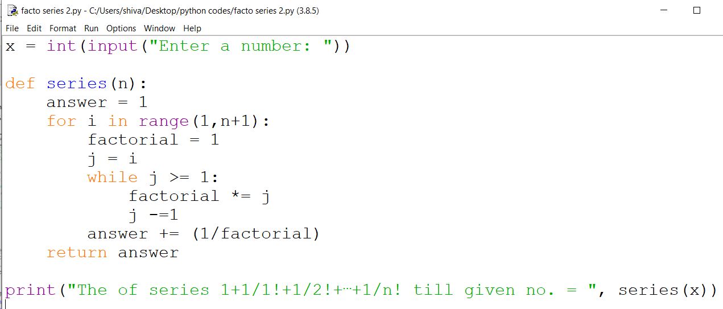

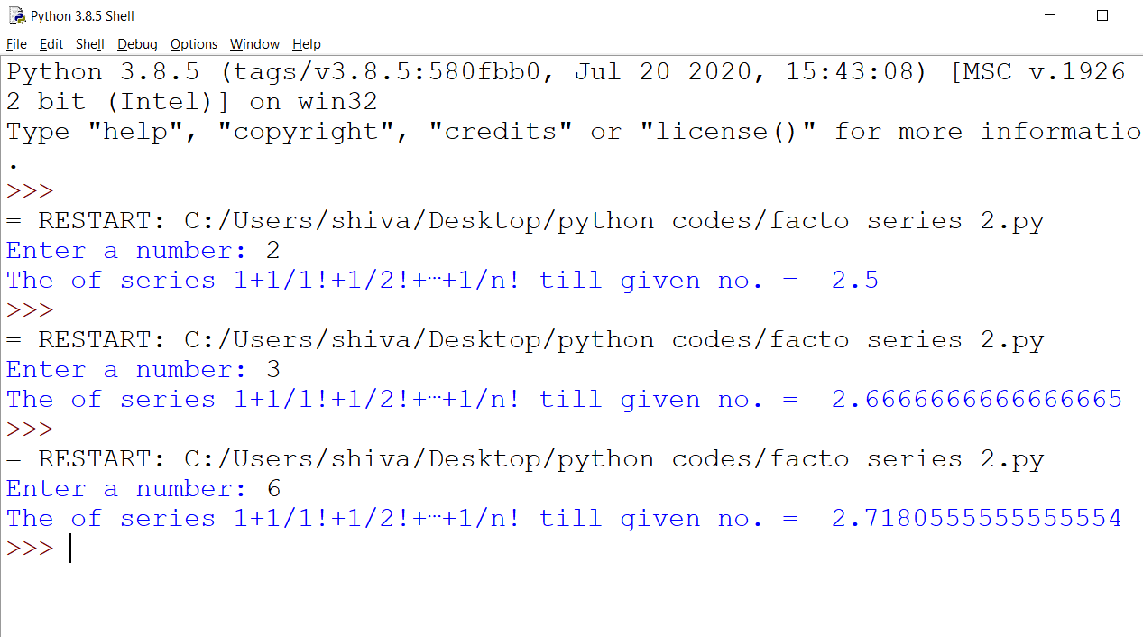

Program 3: Write a program to find whether an inputted number is perfect or not

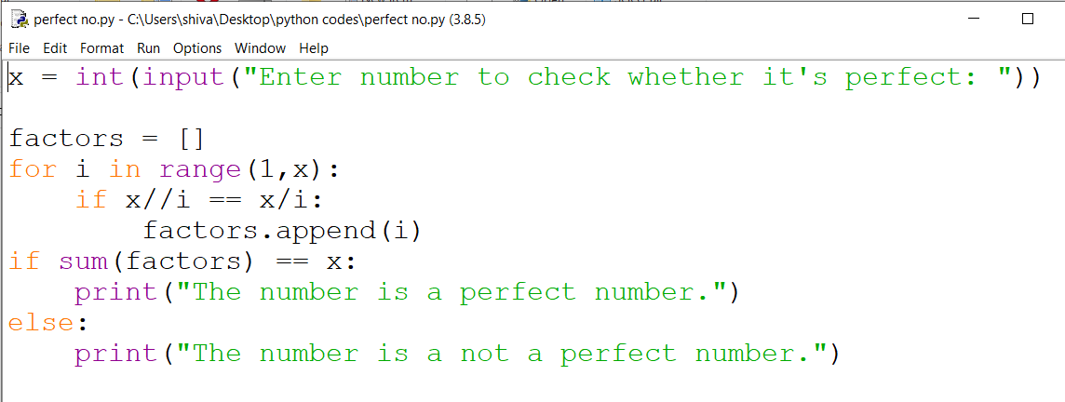

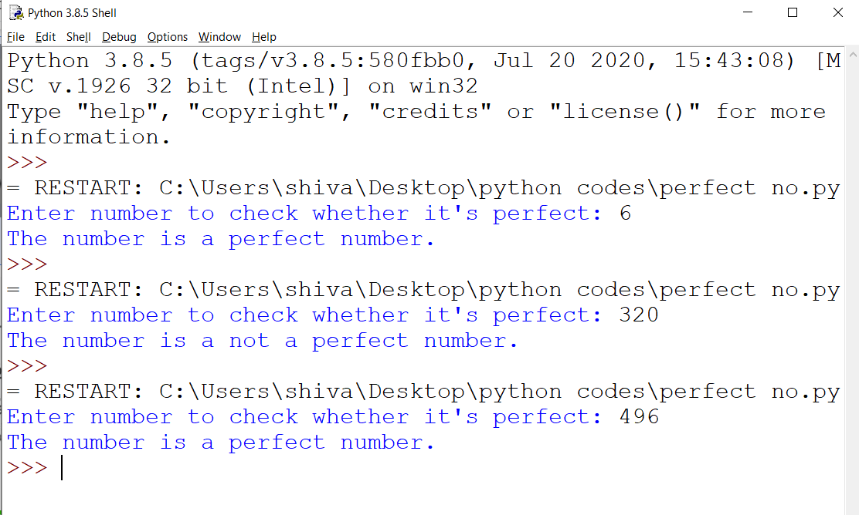

Program 4: Write a Program to check if the entered number is Armstrong or not.

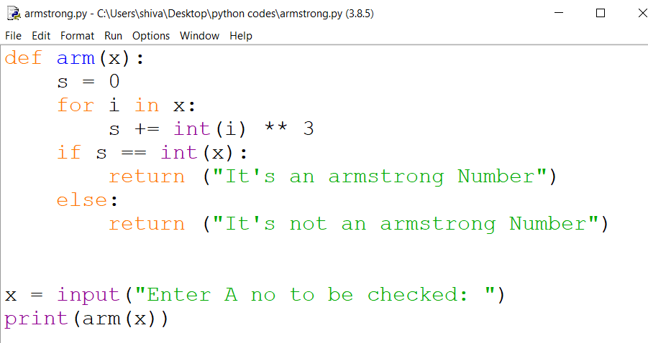

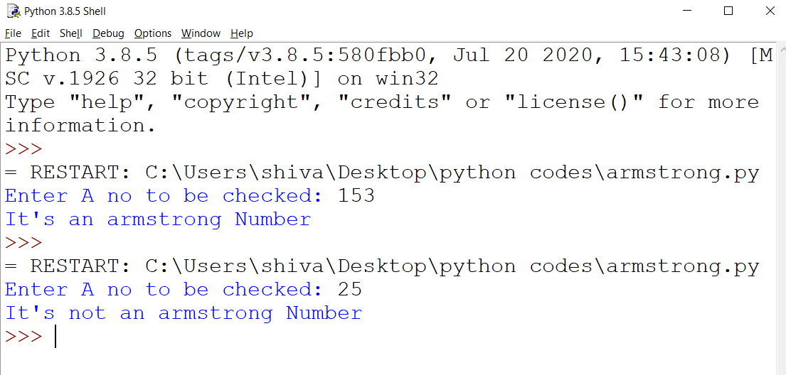

Program 5: Write a Program to find factorial of the entered number.

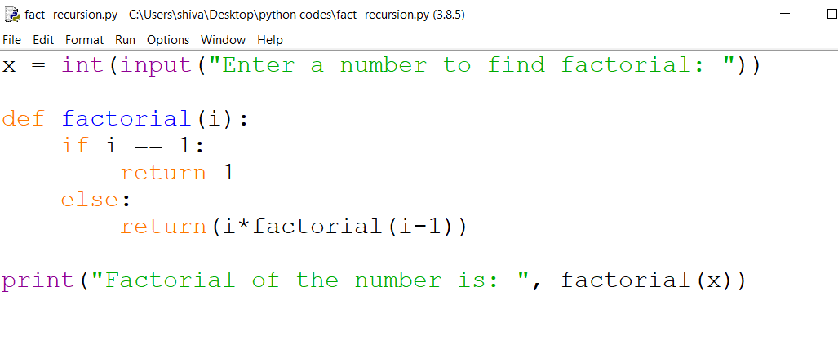

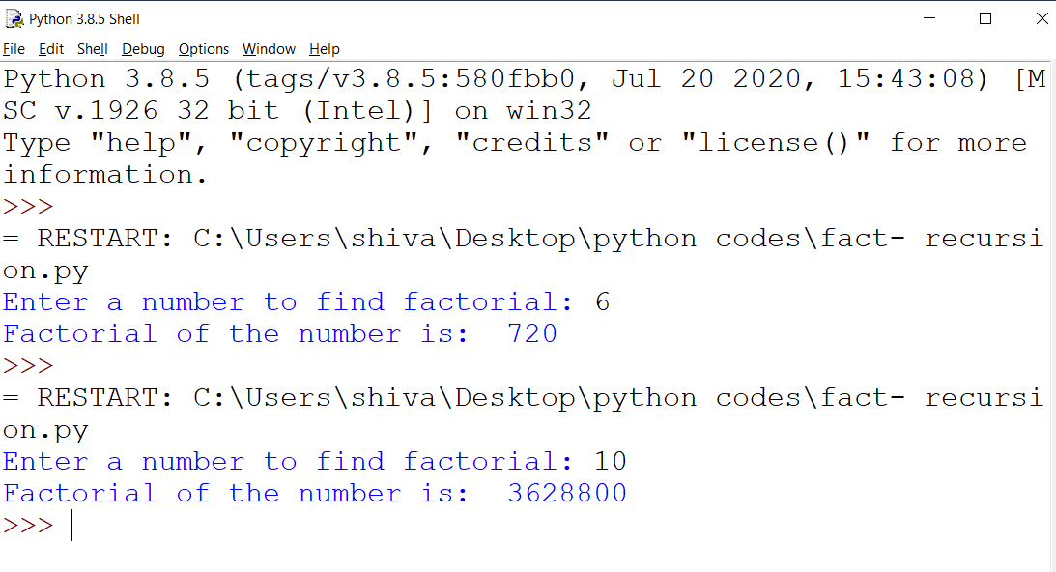

Program 6: Write a program to perform bubble sort on a list of values accepted from the user

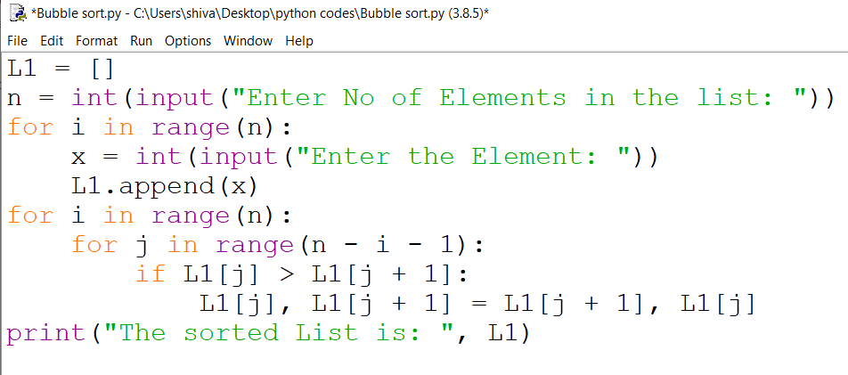

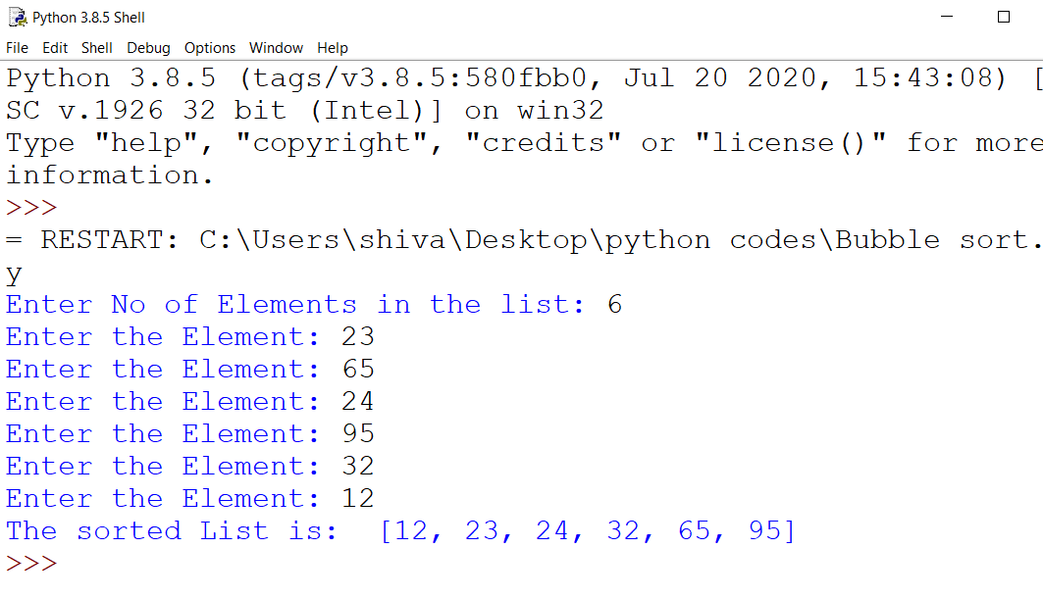

Program 7: Write a Program to enter the string and to check if it’s palindrome or not using loop.

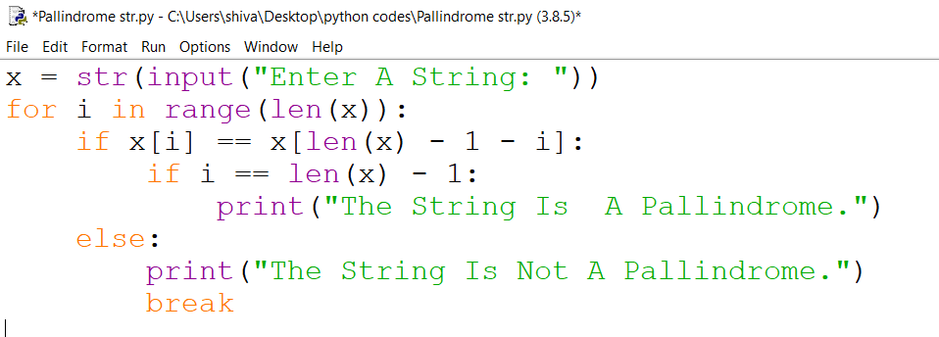

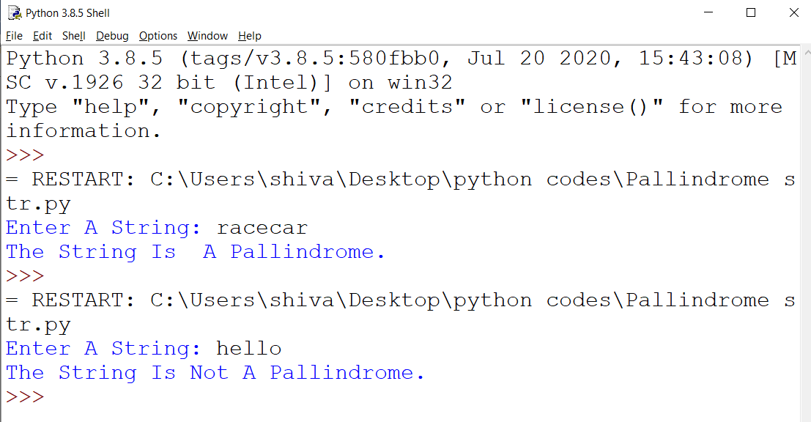

Program 8: Recursively find the factorial of a natural number.

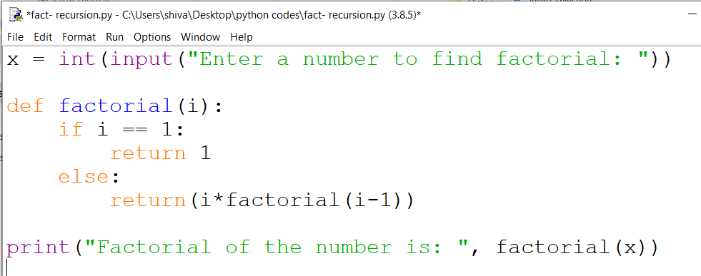

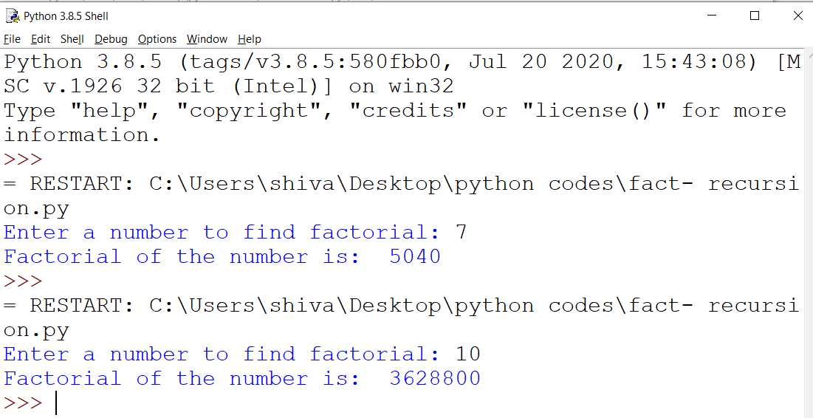

Program 9: Write a program to perform binary search, where the number and the list is taken as arguments in the function bserarch().

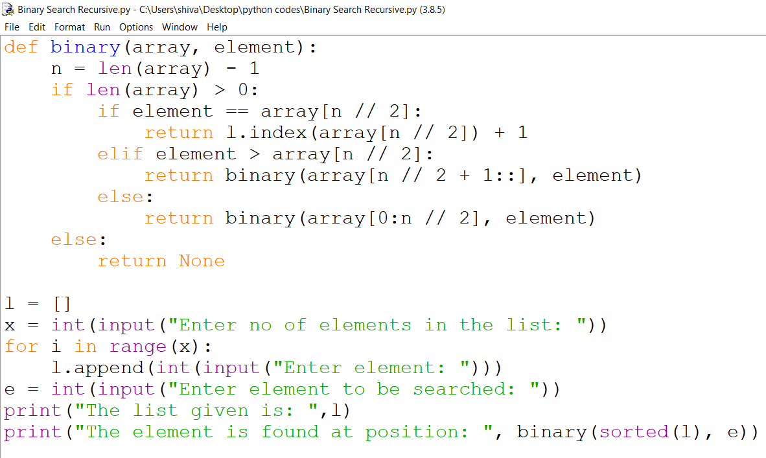

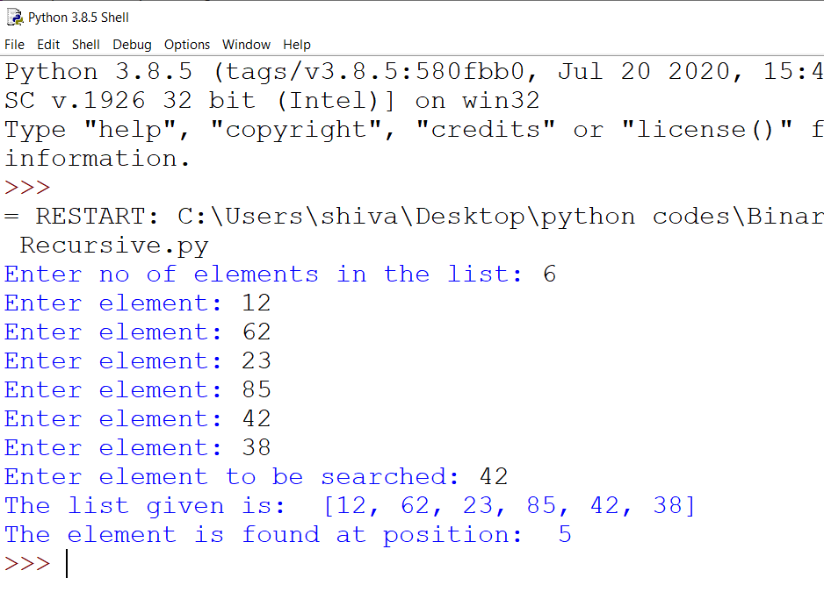

Program 10: Remove all the lines that contain the character “a” in a file and write it into another file.

Program 11: Read a text file and display the number of vowels/consonants/ uppercase/ lowercase characters in the file.

Program 12: Create a binary file with name and roll no. Search for a given roll number and display the name, if not found display an appropriate message.

Program 13: Write a random number generator that generates random numbers between 1 and 6(simulates a dice)

Program 14: Write a menu-based program python program to implement a stack using a list data structure. The menu should contain the option 1. Push, 2. Pop, 3. Display, 4. Exit.

Program 15: Write a menu-based program to perform the operation on queue in python.

Program 16:  Write a program to read data from a csv file and write data to a csv file.

Program 17 Read a text file line by line and display each word separated by a #

Program 18: Write a program to count the number of times the occurrence of 'is' word in a text file.

Program 19: Write a program to write those lines which have the character 'p' from one text file to another text file.

Program 20: Write a program to connect Python with MySQL using database connectivity and perform the following operations on data in database: Fetch, Update and delete the data.